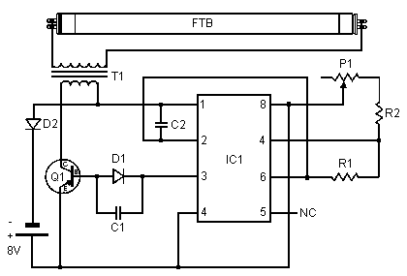 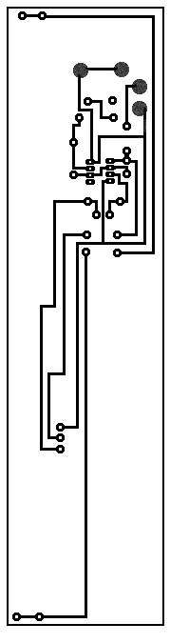 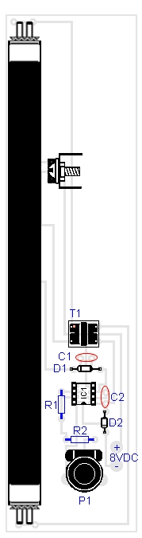 C1- 0.0047uf Mono Capacitor; C2- 0.1uf Disc Capacitor; D1, D2- 1N4007 Diode; FTB- Filtered Blacklight Tube; IC1- 555 Timer IC; P1- 10k Trim Pot; Q1- TIP30 PNP Power Transistor; R1- 470 Ohm Resistor; R2- 270 Ohm Resistor; T1- Medium Yellow Inverter Transformer; MISC- IC Sоcket, Heat Sink For Q1.

Подключение ульрафиолетовой лампы.